4-Channel Infrared IR Line Tracking Detection Sensor Module Stable for Arduino

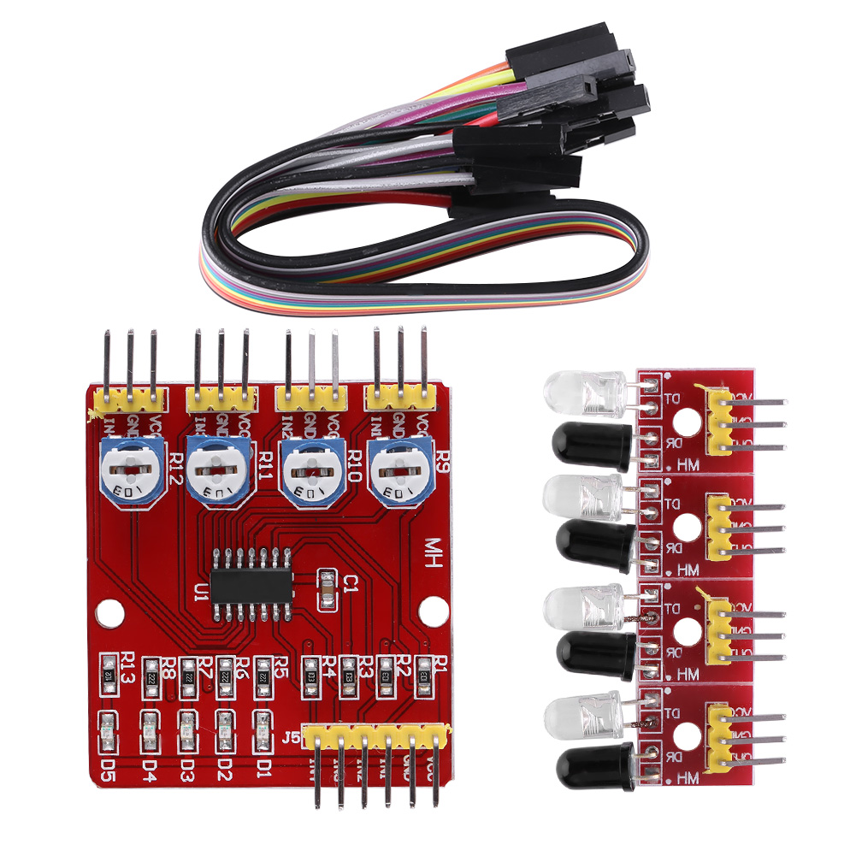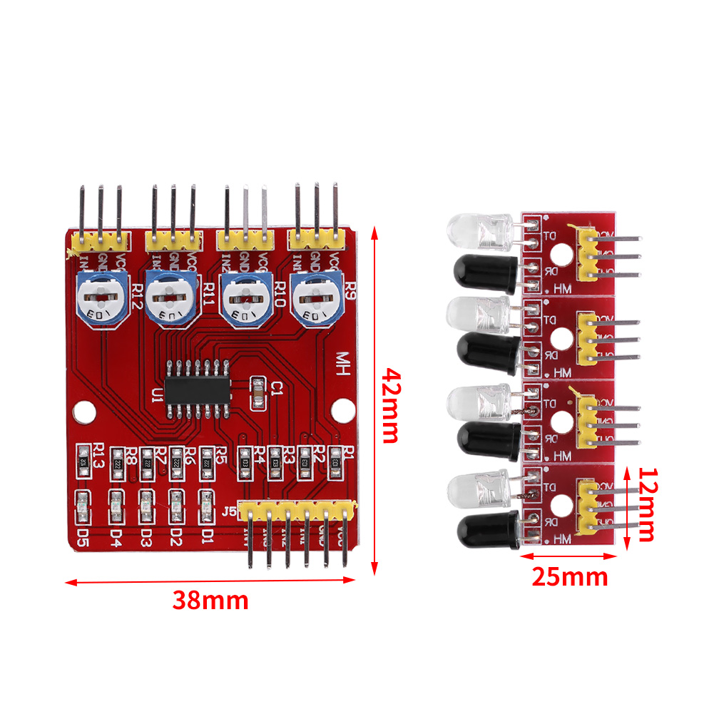

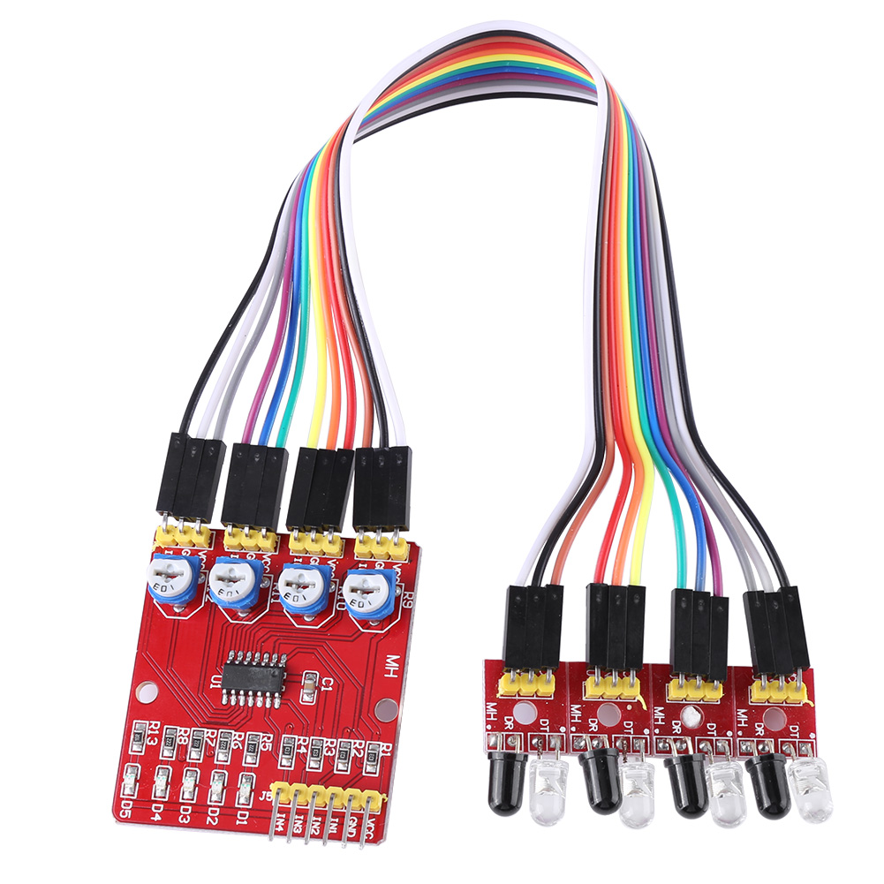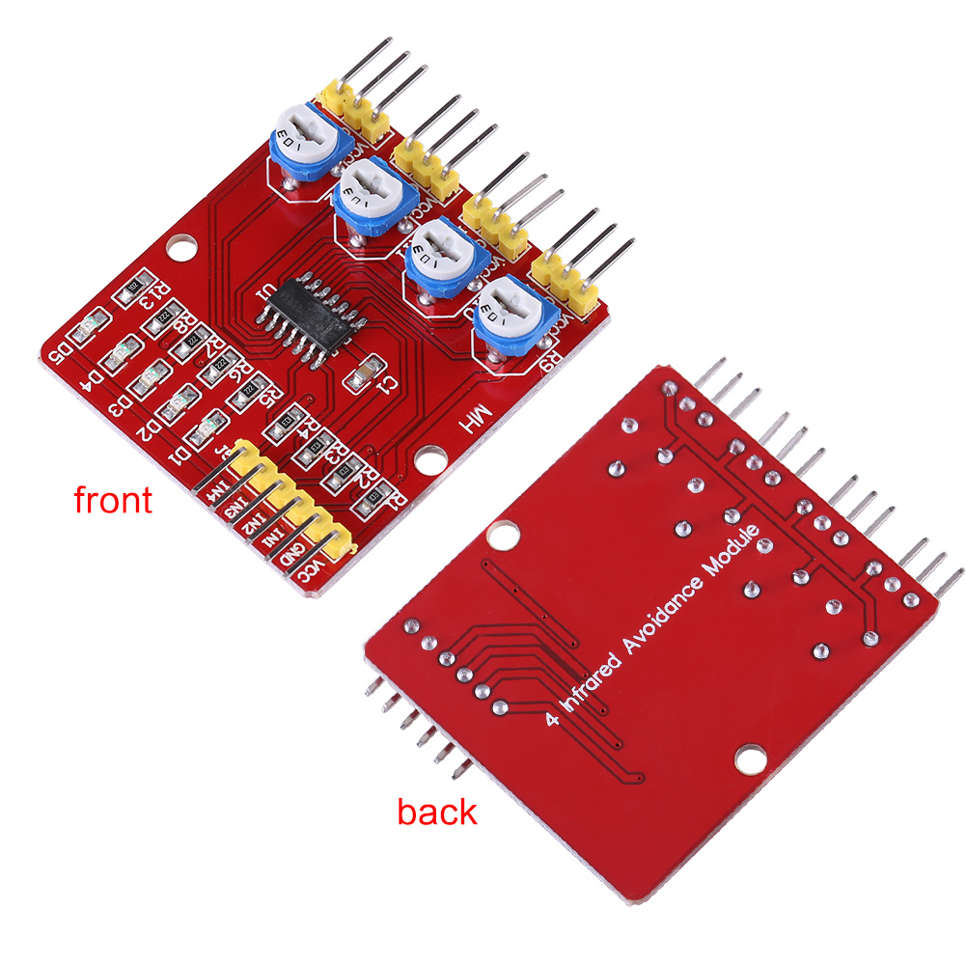

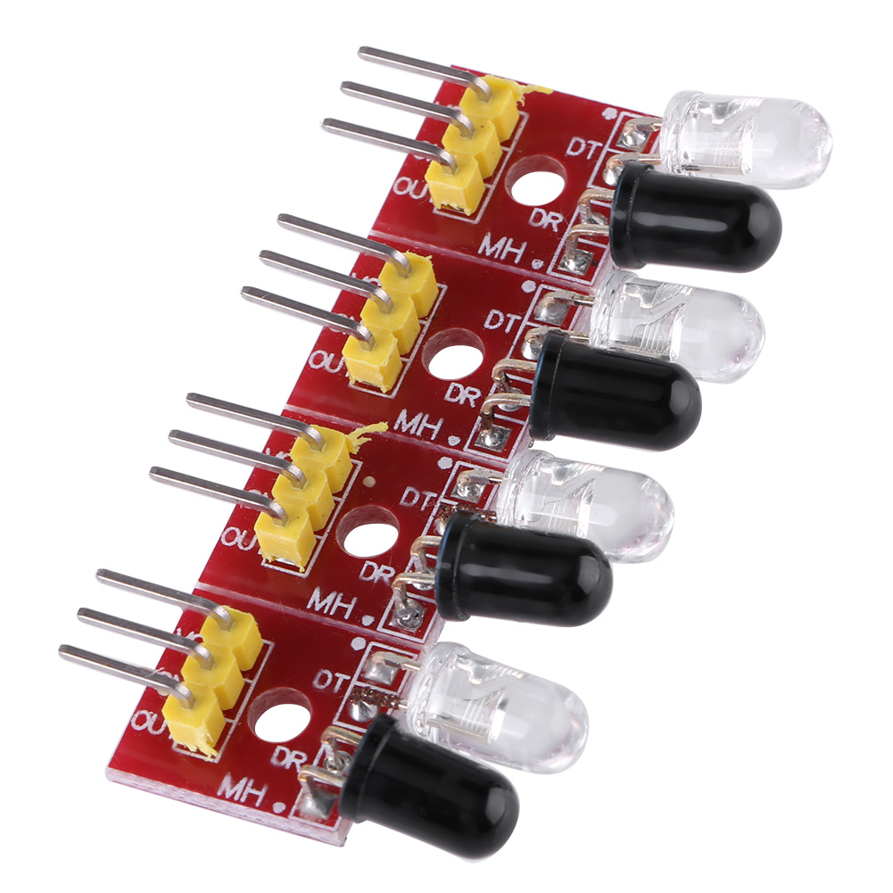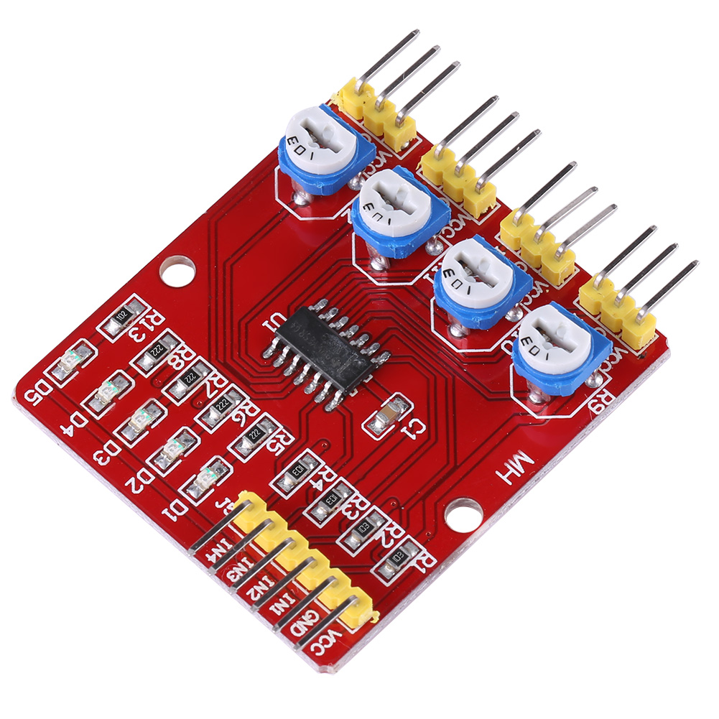

● Details

**Description:**  
This module provides a versatile infrared detection system solutions for automation machinery devices such as smart cars, robots. The sensor module is adaptable to ambient light. It has a pair of infrared transmitting and receiving tube. Transmitting tube sends out a certain frequency IR which will be reflected when detecting obstacles (reflecting surface) and received by receiving tube. After processing with comparator circuit, signal output interface outputs digital signal (a low voltage level signal).

**Features:**

* When the module detects obstacles signal, red indicator lights on and OUT port continuous outputs low voltage level signals at the same time.
* Detection distance can be adjusted with potentiometer, clockwise to increase and counterclockwise to reduce.
* Target reflectivity and shape is the key  point of detection distance. Small and black objects have minimum detection distance, while large and white ones have maximum distance.
* Output port can be directly connected to the SCM IO port, also can drive a 5V relay module or buzzer module directly.
* Widely used in robot obstacle avoidance, car obstacle avoidance, assembly line counting and black white line tracking.

**Specifications:**

Working Voltage: 3.3V-5V DC

Working Current: >1A

Detection Distance: 2~60cm

Detection Angle: 35°  
Size:  
Big Board: 42*38*12mm  
Small Board: 25*12*12mm

Mounting Hole Diameter: 3mm

**Note:**  
1, Do not put probe toward sunlight. Sunlight will cause interference to module.  
2, Sensitivity should not be regulated excessively high because high sensitivity can easily lead to false trigger.

**Package Includes:**

1 x Infrared Tracking Module Set